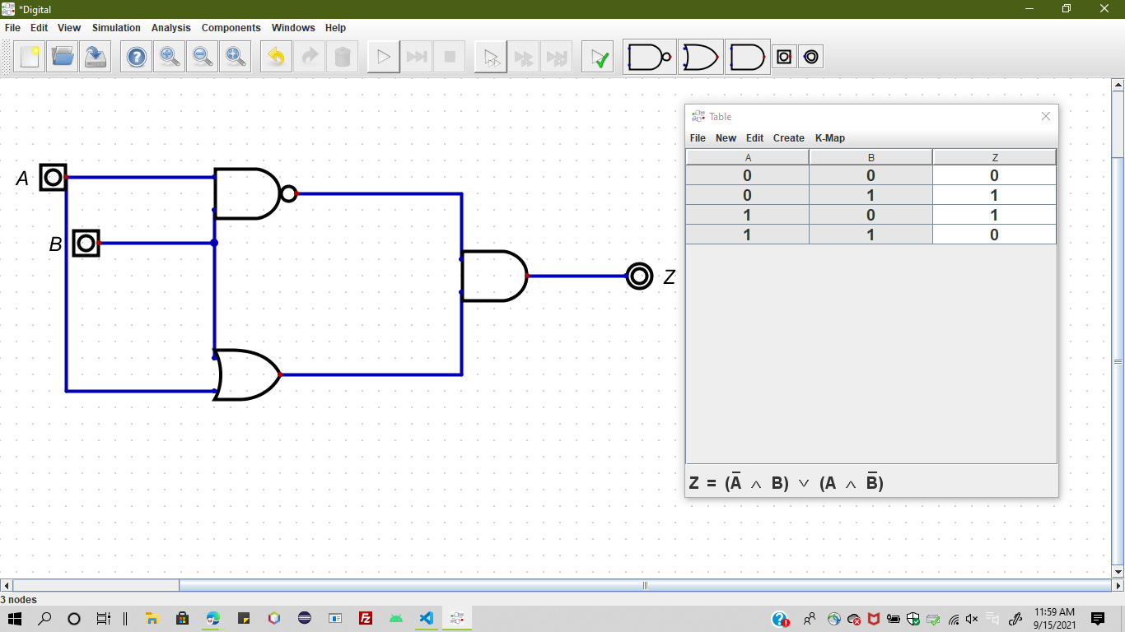

Task:1

Two inputs A and B..inputting for two different gates one as Not And gate and other is a OR gate...the result from two gates and to a AND gate to the output.

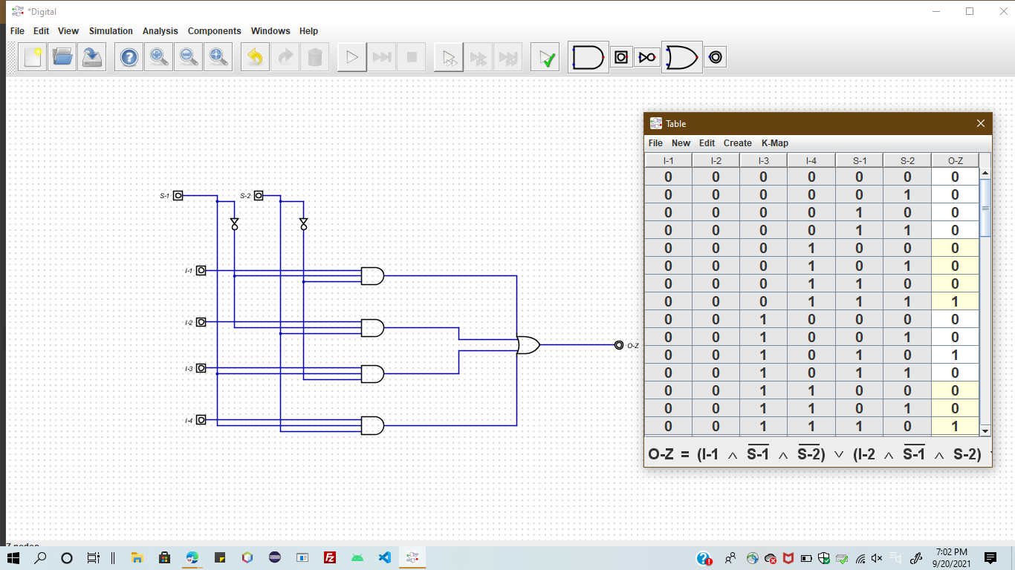

Task:2

Two selectors with inputs as NOT gates into Four AND gates with different levels reaching to single OR gate to form an output.